Packet Tracer – Who Hears the Broadcast? (Instructor Version)

**Instructor Note**: Red font color or Gray highlights indicate text that appears in the instructor copy only.

1. Topology

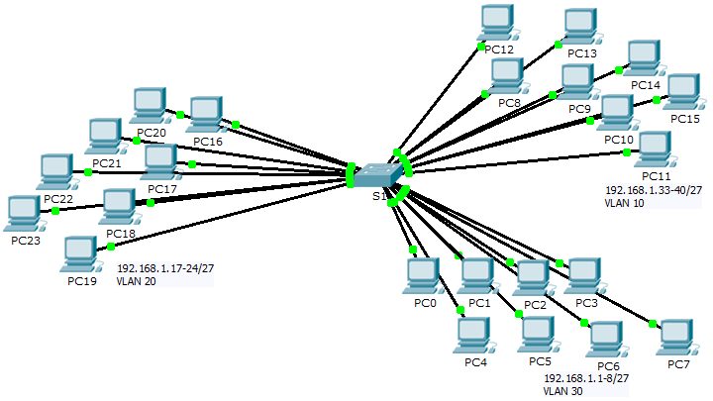

1. Objectives

Part 1: Observe Broadcast Traffic in a VLAN Implementation

Part 2: Complete Review Questions

1. Scenario

In this activity, a 24-port Catalyst 2960 switch is fully populated. All ports are in use. You will observe broadcast traffic in a VLAN implementation and answer some reflection questions.

1. Observe Broadcast Traffic in a VLAN Implementation
   1. Use ping to generate traffic.
      1. Click **PC0** and click the **Desktop** tab> **Command Prompt**.
      2. Enter the **ping 192.168.1.8** command. The ping should succeed.

Unlike a LAN, a VLAN is a broadcast domain created by switches. Using Packet Tracer **Simulation** mode, ping the end devices within their own VLAN. Based on your observation, answer the questions in Step 2.

* 1. Generate and examine broadcast traffic.
     1. Switch to **Simulation** mode.
     2. Click **Edit Filters** in the Simulation Panel. Uncheck the **Show All/None** checkbox. Check the **ICMP** checkbox.
     3. Click the **Add Complex PDU** tool, this is the open envelope icon on the right toolbar.
     4. Float the mouse cursor over the topology and the pointer changes to an envelope with a plus (+) sign.
     5. Click **PC0** to serve as the source for this test message and the **Create Complex PDU** dialog window opens. Enter the following values:
* Destination IP Address: 255.255.255.255 (broadcast address)
* Sequence Number: 1
* One Shot Time: 0

Within the PDU settings, the default for **Select Application:** is PING. What are at least 3 other applications available for use?

DNS, FINGER, FTP, HTTP, HTTPS, IMAP, NETBIOS, PING, POP3, SFTP, SMTP, SNMP, SSH, TELNET, TFTP and OTHER

* + 1. Click **Create PDU**. This test broadcast packet now appears in the **Simulation Panel Event List.** It also appears in the PDU List window. It is the first PDU for Scenario 0.
    2. Click **Capture/Forward** twice. What happened to the packet? The packet is sent to the switch and then broadcast to all of the PCs that belong to the same VLAN and in this case, VLAN 10.
    3. Repeat this process for **PC8** and **PC16**.

1. Complete Review Questions
   1. If a PC in VLAN 10 sends a broadcast message, which devices receive it? All end devices on VLAN 10
   2. If a PC in VLAN 20 sends a broadcast message devices receive it? All end devices on VLAN 20
   3. If a PC in VLAN 30 sends a broadcast message devices receive it? All end devices on VLAN 30
   4. What happens to a frame sent from a PC in VLAN 10 to a PC in VLAN 30? It will be dropped because they are not on the same VLAN.
   5. Which ports on the switch light up if a PC connected to port 11 sends a unicast message to a PC connected to port 13? Ports 11 and 13 will light up.
   6. Which ports on the switch light if a PC connected to port 2 sends a unicast message to a PC connected to port 23? The packet will be dropped.
   7. In terms of ports, what are the collision domains on the switch? Each port is its own collision domain.
   8. In terms of ports, what are the broadcast domains on the switch? Each VLAN is its own broadcast domain.
2. Suggested Scoring Rubric

There are 10 questions worth 10 points each.